**Recommendation for a new US Government Jobs webpage:**

**Goal:**

Re-design the jobs page to get qualified applicants to apply for most difficult-to-fill jobs.

**Reasons why jobs are not getting filled:**

1. Candidates aren’t visiting the hard-to-fill job pages.
2. Hard-to-fill jobs are not easily accessible even by qualified candidates.
3. People with the right talent for these hard-to-fill jobs choose to work for another private/publicly-traded organization.

**Solutions:**

1. To solve the problem of qualified candidates not visiting the hard-to-fill jobs, we re-design the jobs page to make these “featured jobs” more accessible and appealing. The landing page should be modified to encourage users to start finding jobs. If they are presented with the screen below (after adding logos and other details), they are very likely to choose one of the two options.

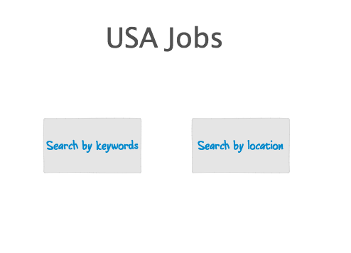

If they choose “keywords”, they will be presented with the following screen. This is a slight modification to the existing screen. This will be changed to According to my analysis; the top three departments with most number of hard-to-fill jobs are NASA, Department of Transportation and Department of Homeland Security. So the second half of the screen will provide a video of these three organizations to portray them in a very positive and attractive way. The goal is to make the users explore the opportunities in these departments. Another minor difference is the addition of a new radio button – “non US citizens”. Reading through some pages, I found that non-US citizens can apply to these jobs but must contact the agencies directly. This radio button can take the user to a page with the required information.

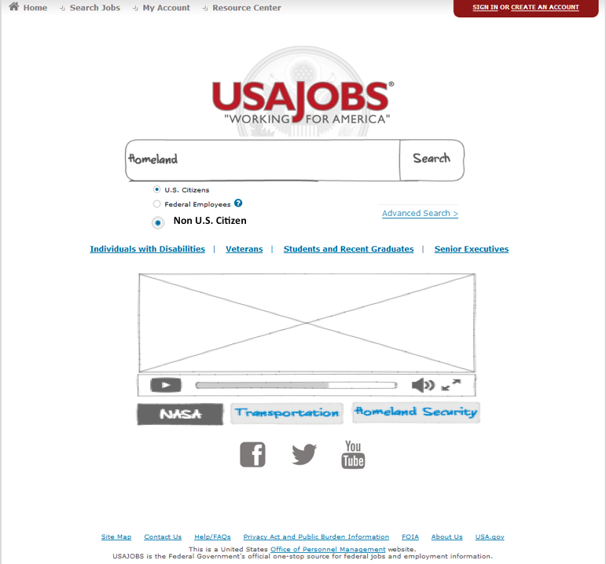

If they choose location, they will be presented with the following screen showing a map of the US. The color helps the user identifies states with most number of jobs. When a user clicks on a state, the next screens would be something similar to what exists with a refined easy-to-use UI.

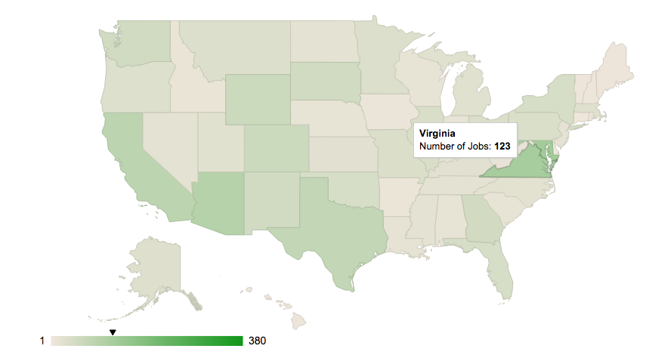

1. To solve the problem of qualified candidates not being able to view these hard-to-fill roles, we can modify the search to provide auto-completion based on what the user has typed. You can see how the new search box would look from the above screen. When the user starts to type something, a drop down with a list of recommended links appear. We could add these “featured jobs” if appropriate. It would look like:

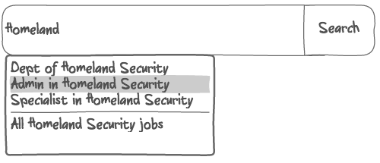

Another addition to this would be adding department filters directly in the search. Suppose the user first searches for “Homeland”, in the second screen where the results are displayed, the search box would have “homeland” pinned to the search. So any further queries will be done on top of these retrieved results. This helps the user access the jobs that are appropriate.

3. Solving the third problem is related to changing the users perspective of what it is to work for the US government. We can argue that, people in this category won’t even use the usajobs.gov webpage. This effort will involve the HR departments to reach out to these highly skilled professionals through social networks like LinkedIn and highlight the incentives of working for their agencies. One of the most effective ways of recruiting is through referrals. The HR department in the US government can introduce referral schemes for their employees and offer additional bonuses for these hard-to-fill jobs. This way, there is a better chance of getting the word out to the appropriate candidates.